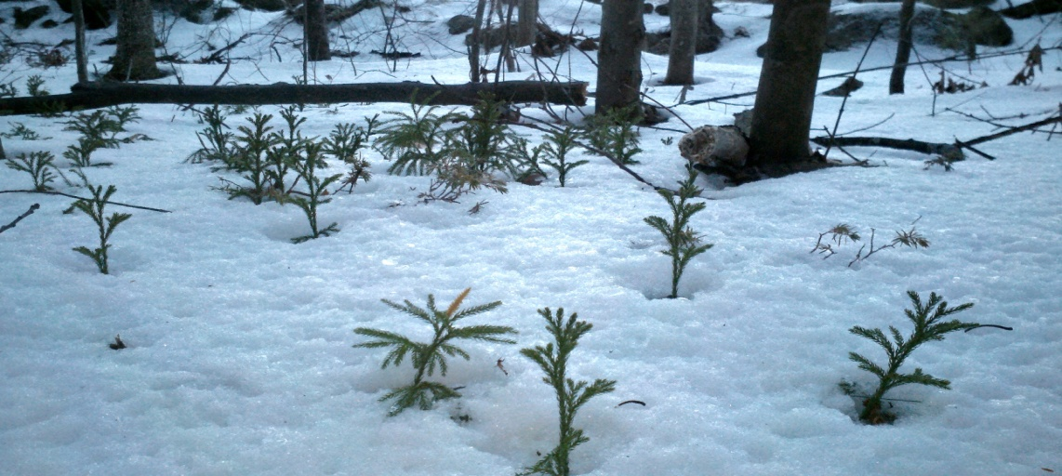

Asking the Right Question Martin B. Copenhaver

Nov 18, 2016 Still Speaking Daily Devotional

"No eye has seen, nor ear heard, nor human heart conceived, what God has prepared for those who love God." - 1 Corinthians 2:9
Nostalgia is a particular temptation these days for those who care about the church and see the church changing in ways that can look a lot like diminishment. We hear, or find ourselves thinking, "The church is not what it once was. The church used to be stronger, more vital. The best days are behind us." Or so nostalgia whispers in our ear.
Nostalgia can be our response to what I call "the narrative of decline." According to this narrative, the church is not what it once was. It is in decline. We hear this narrative all the time these days, but I, for one, am weary of it. The narrative of decline not only is a boring narrative, it doesn’t draw the best from us. It invites blame: Who got us into this situation?
By contrast, we can ask, "What is God is up to in our time?" That’s a very different question. It invites our imaginations. It calls us to be faithful.
As Christians we are assured that the good old days, no matter how good, are nothing compared to what God has in store for us. Paul quotes Isaiah to remind the Corinthians, and perhaps also to remind himself: "No eye has seen, nor ear heard, nor human heart conceived, what God has prepared for those who love him."
So look back, yes. But lean forward. God is up to something new in our time. It is up to us to discern what that is, and to get with the program.
Prayer God, help me to look back in ways that that help me move forward into the future you have prepared for us.
Upcoming Events

- November 27 First Sunday of Advent The waiting begins for this very special holiday in the life of our church.
- Dec 4 Greening We will be doing the church “greening” on Dec 4 after worship service. Come, join in the spirit of the season by decorating God’s house.
- Community Supper Dec 8. 5:30 to 7pm Ham and beans, and all the trimmings! Relax with neighbors and friends for a shared meal and conversation. Still free, and full of the energy of our community.
- Living Room Coffee House Dec 10th. Come at 6:30 to sign up for open mic, or just to relax with a snack before the music starts at 7pm. Note this is the 2nd Saturday—a one time exception to the 3rd Saturday routine.
- Dec 16th Conversations with Women
Gather at 2pm in Mason Church for coffee/tea and share in this first gathering for women of the community and church. Topics are whatever comes up! This is a 'connect and enjoy' time for us. We may have a more concrete purpose or not! While we visit, Michelle will lead us in the joy of Zentangle--an 'anybody can' drawing project
- Dec 18th Children’s Pageant The pageant will take place as a part of our worship service, so don’t miss this special telling of Tomi DePaolo’s story of the season.
- Dec 18th Community Caroling We will gather for carpooling at 3:30pm to travel to the homes of shut-ins in the community. At about 6-6:30 we return to church for a meal of chili/soup, and salad. All are welcome to participate. Call Bettie Goen with any questions or if you have someone to add to our list of people. 878-2374
- Dec 24th Christmas Eve service at 7 pm Bring family and friends to share in the traditional “Lessons and Carols” service that will end with a candlelit singing of Silent Night.
- Soup Kitchen mission Signup sheet will be on the bulletin board. Dates are January 14, February 11, and March 11 SAVE the DATES! Our first trip in August was a great success, ask Kathy Chapman, 878-4993, about the event, and get an idea of the need, fun, and the work.
- Lending Library Notice the fine bookshelf in Fellowship Hall that has books for lending—all nicely organized, and alphabetized by a church angel. Steve Tamulonis has contributed some CDs for lending/listening. Please sign them out, and return in a reasonable time. Enjoy this mission/blessing.
- Spend some of the dark Winter hours knitting Yarn into Prayer Shawls! Join the knitters of Mason Church in prayerful knitting. If you know someone who needs the warmth and prayers of a shawl please contact: Susan Suokko at Usercat2@comcast.net or 941-920-0270 or Michelle Scott 878-1680
- Curt Dunn and Karin Eisenhaure. Remember them in your thoughts and prayers as sometimes life is quite challenging. Among the many things Karin and Curt do for Mason Church, we thank them for their support of the Coffee House—both in attendance and in providing treats and kitchen organization.
- Dotsie Millbrandt Please keep the family in prayer. Dotsie is very busy with care of both Wolfgang and his mother, as well as Archie the dog, and the ducks! Emails and cards are welcome. She will let us know how else we can assist. Dotsie24@gmail.com or 1322 Starch Mill Rd, Mason, NH 03048.
- Joe and Jennie Walsh and Joshua, Jonathan and Joseph are always in our hearts and thoughts. Update as of 11/7: Joe is doing much better after having his tonsils removed which was causing his idiopathic angioedema. He hopes to go back to work soon. Jenny is working in the daycare center that her mother runs, and the boys love their school, and activities. Call, write, or email them with your news! Their address is: 50 Clinton Ave, Chelmsford, MA 01824 978-256-6700 Jwalsh131@comcast.net
- Arthur Rafter. Arthur Rafter’s celebration of life service was November19, 2016. At memorial services people always say nice things, but few are raised as high as “hero, role model for us all,” and more along those lines. Arthur’s quiet ways did not go unnoticed in his community, or with his family. Send family condolences to Jane and Gary Goodhart, 19 Meadow Ln, Pleasant Valley, NY 12569. (I will get contacts for his other sons by next month. It is never too late to send condolences)
- Cindy Tibbetts Cindy and Jim are in Milford, but also in our thoughts! She may need rides to church when Jim or her parents can’t do this. Give Cindy a call at 809-2036. New Address: Cahill Place, 486 Nashua St. Milford 03055
- Lilia Washburn She is always in our hearts, but I bet she would love to know it. She was ill this first week of November, but hopefully will be on the mend soon. Laila Washburn, c/o Brett Kivela, 25 Will Road, New Ipswich 03071. Although visitors are welcome from 10am to 7pm, it is good to call first. 878-3065
- Gretchen Brown has limited mobility these days, and loves visitors. You can call ahead 878-1481 or stop by. Gretchen is on a special diet in an effort to alleviate her chronic pain. It is gluten free, but also has other limitations. Please call Michelle if you need help with ideas or details 878-1680 or miscott39@gmail.com
- Do you know someone who needs spiritual support or other support, of the pastor and deacons? Please call, your church family may be able to help. Leave a confidential message for Pastor Veronica Don at 603-878-1684 or on her personal phone at 603-213-6368.

Our Sustainability Mission: Mason Conservation Committee provides special blue plastic bags for roadside trash collection which you can leave on the side of the road for town pickup. Pick up the blue bags at Charlie’s Auto Shop on Jackson Rd, or we will have a supply at church. Please put recyclable items into a separate bag you can take to the Wilton Recycling Center, or put them into our recycling bins in our church kitchen. . Please bring only paper products (no Styrofoam) for church events, avoid plastic water bottles, and use the dishware/dishwasher whenever you can. Recycle paper, cardboard, #1 plastics, and milk bottle plastic, as well as all glass and cans. Large cans for these are in the kitchen.

Any news items, comments, or things you would like to share: contact Michelle at 878-1680 or miscott39@gmail.com

“Do all the good you can, by all the means you can, in all the ways you can”

